

COUNTY GOVERNMENT OF KAKAMEGA

COUNTY PROJECT IMPLEMENTATION
REPORT

FY 2013 - 2016

FEBRUARY, 2017

Making Development Possible

PREAMBLE
This report is an in-depth analysis of all the projects and programmes that the County Government of Kakamega (CGK) has implemented over the years since the inception of the county government. The report looks at the sectorial projects and programmes with a specific focus on project activities, location of the project and their status. The sectors within CGK include: Health services, Ministry of Transport, Infrastructure, Public Works & Energy, Ministry of Trade, Industrialization & Tourism, Ministry of Public Service & Administration, Ministry of Lands, Housing, Physical Planning & Urban Areas, Ministry of Education, Science & Technology, Ministry of Social Services, Youths & Sports, Ministry of Water, Environment & Natural Resources, and the County Treasury.

Contents
PREAMBLE ii
1.0 HEALTH SERVICES 1
2.0 MINISTRY OF TRADE INDUSTRIALIZATION AND TOURISM 6
3.0 MINISTRY OF TRANSPORT, INFRASTRUCTURE, PUBLIC WORKS AND ENERGY 12
4.0 MINISTRY OF PUBLIC SERVICE AND ADMINISTRATION 21
5.0 OFFICE OF THE GOVERNOR 24
6.0 MINISTRY OF LANDS, HOUSING, PHYSICAL PLANNING AND URBAN AREAS 26
7.0 MINISTRY OF AGRICULTURE, LIVESTOCK, FISHERIES AND COOPERATIVES 28
8.0 MINISTRY OF EDUCATION, SCIENCE AND TECHNOLOGY 34
9.0 MINISTRY OF SOCIAL SERVICES, YOUTH AND SPORTS 42
10.0 MINISTRY OF WATER, ENVIRONMENT AND NATURAL RESOURCES 45

LIST OF TABLES
Table 1: Health Services projects 5
Table 2: Trade, Industrialization & Tourism projects 11
Table 3: Roads projects for FY 2013/14 14
Table 4: Roads projects for FY 2014/15 17
Table 5: Roads projects for FY 2015/16 20
Table 7: Public Service projects 23
Table 6: Projects in Office of the Governor 25
Table 8: Lands, Housing, Physical Planning & Urban Areas projects 27
Table 9: Agriculture, projects in Bukura ATC 28
Table 10: Agriculture, projects under Cooperatives 29
Table 11: Agriculture, projects under Veterinary 30
Table 12: Agriculture, projects under Crop Production 31
Table 13: Agriculture, projects under Fisheries 32
Table 14: Agruculture, projects under Irrigation 32
Table 15: Agriculture, projects under Livestock Development 33
Table 16: Education, Science & Technology projects 41
Table 17: Social Service projects 44
Table 18: Environment, projects in Water department 48
Table 19: Environment, Projects in Environment Department 50
Table 20: Environment, projects in Natural Resource Department 51

MINISTRY OF AGRICULTURE, LIVESTOCK, FISHERIES AND COOPERATIVES

1.1. Background

The sector Agriculture, Livestock, Fisheries and Cooperative is split into two subsectors that’s Agriculture, Irrigation, Cooperatives and Bukura ATC, and Livestock, Veterinary and Fisheries.

The sector has been a key driver of economic growth in Kakamega and remains the main source of livelihood for the majority of the people. It has also been identified as one of the sectors critical in delivering the economic growth rate under the CIDP
The programmes implemented from 2013-2017 under various sub-sectors within the department include

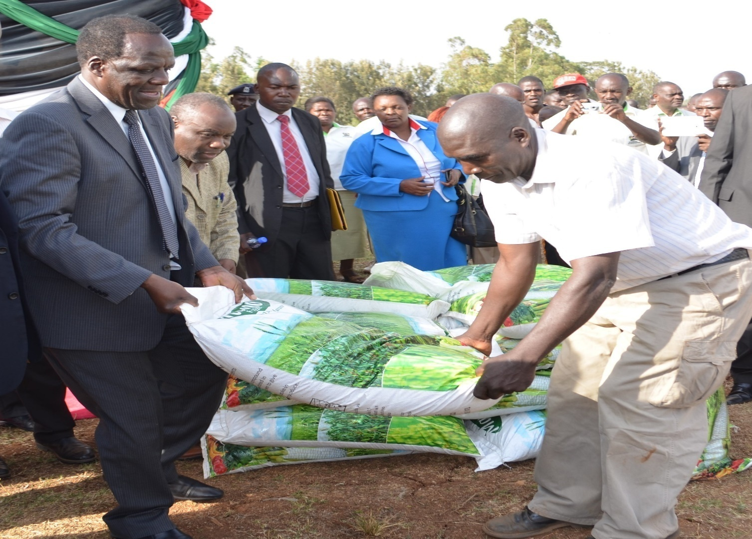
Figure 1 H.E THE Gavonor giving out fetilizer to farmers

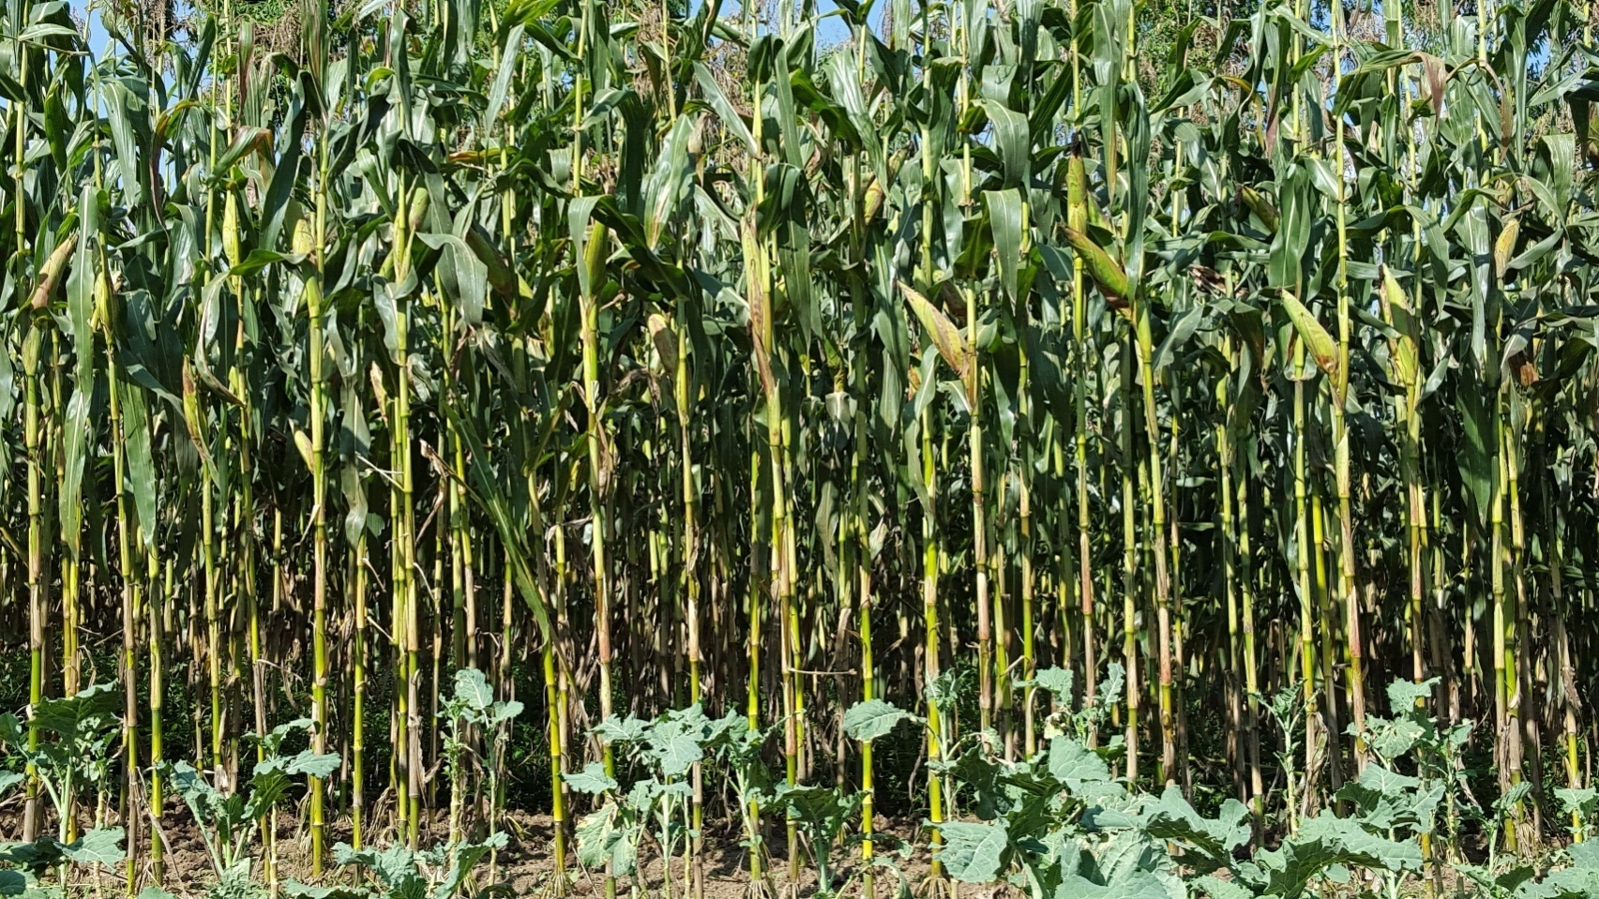
Figure 2Maize under farm subsidy

Project Name | Location | Activities | Status | Remarks
Grants to Small Businesses, Cooperatives and Self Employed |  | Selection of cooperatives, provision of grants | Complete | Khwisero dairy farmers for support on milk storage
Grants to Small Businesses, Cooperatives and Self Employed |  | Capacity building of cooperatives | Complete | Khwisero tea farmers’ cooperative structures in place
Kakamega County Artificial Insemination Programme | All wards | Purchase of Semen, LIQUID Nitrogen, Hormones, | Continuous | 1,221 inseminations done.
Veterinary Laboratory | All wards | Procure equipment  Rehabilitation of the laboratory building | On-going | Rehabilitation of laboratory done partly
Farm inputs | All wards | Purchase and distribution of 9,724 bags of planting and 9,822 bags of top-dressing. 13,071 (2kg pkts) of maize seeds | Complete | Improved maize production.
Banana project | All wards | Purchase and supply of 7,000 plantlets supplied and distributed to farmers. | Complete | Bananas at fruiting stage
Kakamega fish farming and productivity programme |  | New fish ponds construction/ rehabilitation of fish ponds | On-going | 3 earthen/ 1 liner pond 90% complete
 | All wards | Existing fish farmer support subsidies | Complete | 29 farmers received the fish farming subsidies
Dairy Development (One Cow Initiative/Smart Dairy) | All wards | Purchase and distribution of 40 In-calf Heifers | On-going | 22 cows calved down
Poultry Development Program me | All wards | Training of farmers ,supply of day old chicks | On-going | 4,000 chicks distributed
Tea development | All wards | Purchase and distribution of Tea seedlings | Complete | Infilling done
Banana project | All wards | Purchase and supply of 7,000 plantlets supplied and distributed to farmers. | Complete | Bananas at fruiting stage
Tea development | All wards | Purchase and distribution of Tea seedlings |  | Tea infilling done
Kakamega fish farming and productivity programme |  | New fish ponds construction/ rehabilitation of fish ponds | On-going | 3 earthen/ 1 liner pond 90% complete
Kakamega fish farming and productivity programme | All wards | Existing fish farmer support subsidies | Complete | 29 farmers received the fish farming subsidies
Dairy Development (One Cow Initiative/Smart Dairy) | All wards | Purchase and distribution of 40 In-calf Heifers | On-going | 22 cows calved down

MINISTRY OF TRANSPORT, INFRASTRUCTURE, PUBLIC WORKS AND ENERGY

The sector has a broad objectives spread within its four sections namely Transport, Infrastructure, Public Works and Energy. Infrastructure section is concerned with the construction and maintenance of various roads, bridges, box culverts and drainage systems. Energy section develops and manages the energy infrastructure.

BITUMEN ROADS
Project name | Activities | Length (Km) | Status | Remarks
Weliboyi Junct. –Khwisero | Upgrading to bitumen | 6.5 | Ongoing | Well on course
TOTAL |  | 6.5

GRAVEL ROADS
Project name | Activities | Length (Km) | Status | Remarks
Ekonjero-Kilingili-Mulufu | Dozing,  Grading  And  Graveling | 12 | Complete | Operational
Mundeku-Dudi-Ombwaro | Dozing,  Grading  And  Graveling | 12 | Complete | Operational
Shianda Pr.Isiska Bridge Ikomere Sec. Rds. | Dozing,  Grading  And  Graveling | 5 | Complete | Operational
Mulwanda market –R. Yala bridge | Dozing,  Grading  And  Graveling | 2 | Complete | Operational
Ekambuli Pri. –Eshirembe –Mungong’we –Ebukwala Pri. –Mushiangubu –Ukolomani - Opembe | Dozing,  Grading  And  Graveling | 12 | Complete | Operational
Munjiti-eshichibulu-elwangale-emuruba-emulunya-mushikongolo | Dozing,  Grading  And  Graveling | 17 | Complete | Operational

10Km road project
Project name | Length | Ward | Activities | Status | Remarks
Inyanya–Lwandadudi | 3.5Km | Kisa West | Grading, Gravelling and compaction | Complete | Operational
Ikhaba - Quary – shirotsa | 5Km | Kisa West | Grading,Gravelling and compaction | Complete | Operational
AC-khuluwinu | 3km | Kisa West | Grading,Gravelling and compaction | Complete | Operational
AC Primary - Khulu Wihi Bridge | 3.1Km | Kisa West | Grading,Gravelling and compaction | Complete | Operational
Muhakadisp – baomoja | 1.5km | Kisa West | Grading,Gravelling and compaction | Complete | Operational
 | 13Km
Mundombelwa-bwale- Amwiru | 2Km | KisaNorth | Grading,Gravelling and compaction | Complete | Operational
Mwitseshe- mulufu | 2.5km | KisaNorth | Gravelling and compaction | Ongoing | Well on course
Mwihila-eshisango | 1km | KisaNorth | Gravelling and compaction | Complete | Operational
Emusatsiro-emalele | 1km | KisaNorth | Gravelling and compaction | Complete | Operational
Emweru Sec-mushinak | 1km | KisaNorth | Gravelling and compaction | Complete | Operational
 | 7.5Km
Wochiengi - Mwiranje | 3.5km | Kisa Central | Gravelling and compaction | Complete | Operational
Mulwanda - munyanza | 2km | Kisa Central | Gravelling and compaction | Complete | Operational
NamasoliC.o.G – Leche – Khumutibo | 2km | Kisa Central | Gravelling and compaction | Ongoing | Well on course
Ebukanga-mufisi | 2km | Kisa Central | Dozing,grading,gravelling | Complete | Operational
Ocheko-musita | 3km | Kisa Central | Dozing,grading | ongoing | Awaiting gravelling
Emung’abo-ekambuli | 2km | Kisa Central | Dozing | Ongoing | Awaiting,grading gravelling
 | 14.5Km
Munjiti-mukangu | 1.5km | Kisa East | Dozing, and Grading | Ongoing | Awaiting gravelling
Eshiruli-ebuchika | 1km | Kisa East | Grading | Ongoing | Awaiting gravelling
Eshiruli - Emalindi | 2.5km | Kisa East | Grading | Ongoing | Awaiting gravelling
Eshinutsa sec.- church of God | 1km | Kisa East | Dozing | Ongoing | Awaiting gravelling
Emulunya – Emulanda | 3.5km | Kisa East | Dozing | Ongoing | Awaiting gravelling
Emulunya DO’s office- Mundaha | 2km | Kisa East | Dozing | Ongoing | Awaiting gravelling
 | 11.5Km

HEALTH CARE SERVICES

The main objective of the sector is to provide affordable and equitable health care services to the citizens across the Sub County through the provision of quality health services, infrastructure and technologies as shown in the pictures below;

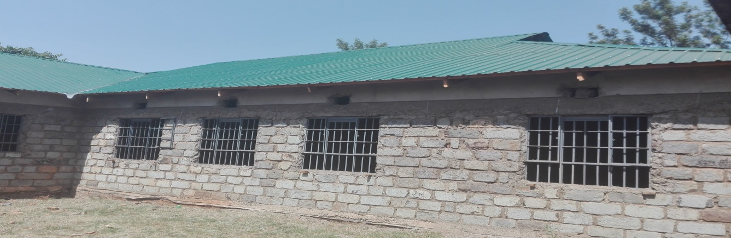
On- going construction of Maternity and Laundry Blocks at Khwisero Sub County Hospital
Project name | Location | Activities | Status | Remarks
Khwisero Sub County Hospital | Khwisero | Construction of a Laundry and Maternity Blocks | Complete | Not Operational
Ekambuli Dispensary | Kisa Central | Construction of the Staff House | Complete | Operationalize the facility by equipping

The Ministry of Education, Science and Technology is one of the key sector under the county government of Kakamega. Since devolution the department has been able to implement various projects and programmes under its mandate, which were anchored on various development plans.
Strategic Goals/Objectives of the Department
- To promote access, Equity, quality and relevant training.
- To equip, refurbish and upgrade infrastructure in early childhood centres and county polytechnics
- To strangthen strategic partnership and linkages in promotion of education
Develop and implement subsidised tuition in polytechnics

Ministry of Education Science and Technology

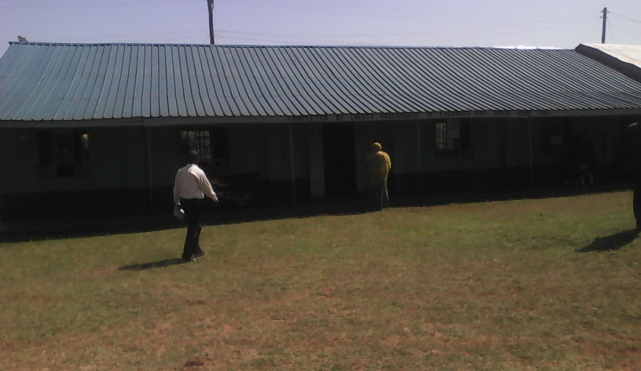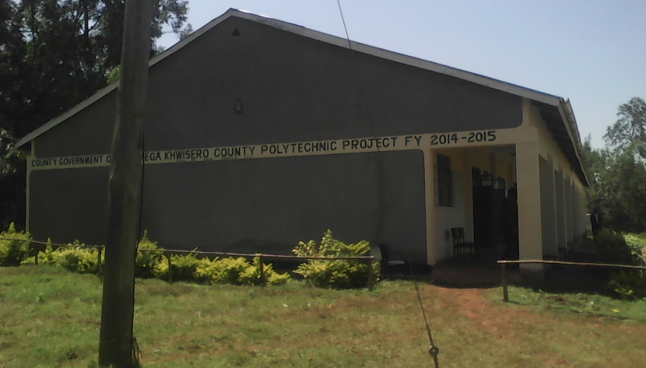
Mwihila Girls secondary 2 Class Room Khwisero County Polytechnic Twin Workshop

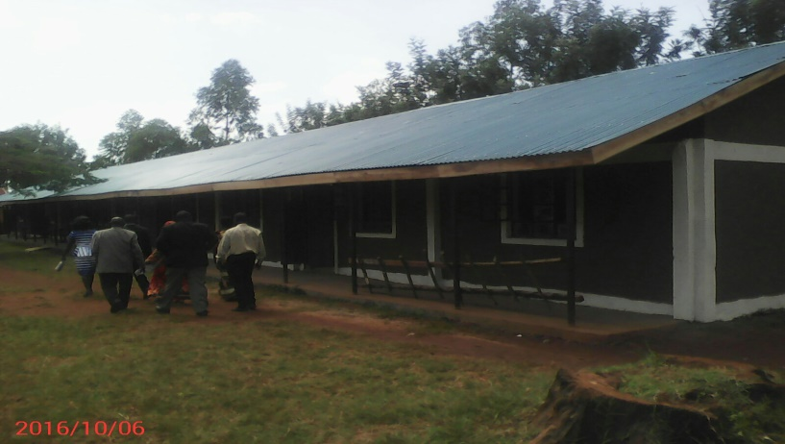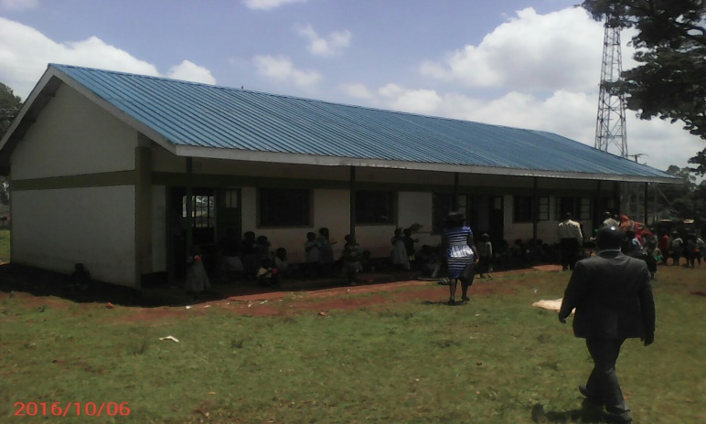

Shiongo Primary 5 No Class Room Mulwanda ECD
Project Name | Location | Activities | Status | Remarks
Eshiabwali County polytechnic | Khwisero | Construction of Twin workshop | Ongoing | At finishing stage
Khwisero County polytechnic - Phase 1 | Khwisero | Construction of Twin workshop | Complete | Commissioned and in use
Khwisero County polytechnic - Phase 2 | Khwisero | Construction of Twin workshop | Ongoing | At finishing stage
Mwikhalikha ECD | Khwisero | Construction of ECD block | Ongoing | At Finishing stage
Emulole ECD | Khwisero | Construction of ECD block | Ongoing | At Finishing stage
Emalindi ECD | Khwisero | Construction of ECD block | Ongoing | At Finishing stage
Munjiti ECD | Khwisero | Construction of ECD block | Ongoing | At Finishing stage
Luanda-Doho ECD | Khwisero | Construction of ECD block | Complete | Waiting to be commissioned and in use
Mulwanda ECD | Khwisero | Construction of ECD block | Complete | Waiting to be commissioned and in use
Nyamboga ECD | Khwisero | Construction of ECD block | Complete | Waiting to be commissioned and in use
Eshikhungula ECD | Khwisero | Construction of ECD block | Complete | Waiting to be commissioned and in use
Mundaha Gilrs | Khwisero | Construction of Administration and Tuition block | Ongoing | At finishing stage
Ekomero Girls | Khwisero | Construction of Classroom | Complete | Waiting to be commissioned but in use
Eshibinga seconadry | Kwisero | Construction of Classroom | Ongoing | At Finishes
Mulufu Primary | Khwisero | Construction of 3 No of classrooms | Complete | Waiting to be commissioned but in use
Shirotsa Primary | Khwisero | Construction of 3 No of classrooms | Complete | Waiting to be commissioned but in use
Eshongo Primary | Khwisero | Construction of 3 No of classrooms | On going | At Completion stage

Ministry of Trade Industrialization and Tourism
The Ministry of Trade industrialization and tourism is one of the key departments under the county government of Kakamega. It is has four key department, namely Trade, Industrialization, Tourism and Weight &measures. The Ministry is responsible for formulating and supporting strategies, plans and programs that promote and ensure expansion and diversification of trade, environmentally sustainable industrialization, tourism, generating wealth for poverty eradication and benefiting Kakamega County socially and economically.
The ministry implemented various projects and programmes in Khwisero Sub- county since the inception of devolution, these are construction of one modern market, refurbishment of one existing market, construction of two stock rings and disbursed Kshs. 4M SME loans to 599 traders within the Sub- county. The details of the said projects are as indicated hereunder:
Sample project;

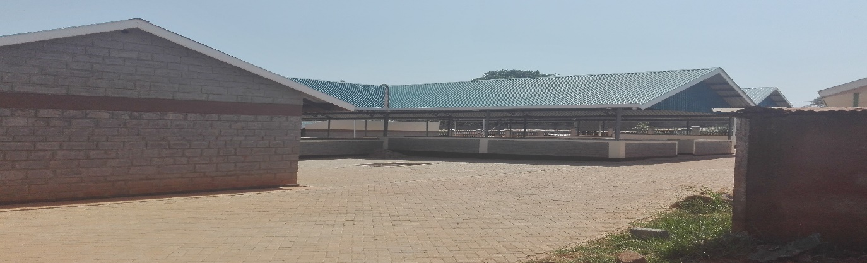
Figure 3 Complete Mulwanda modern market
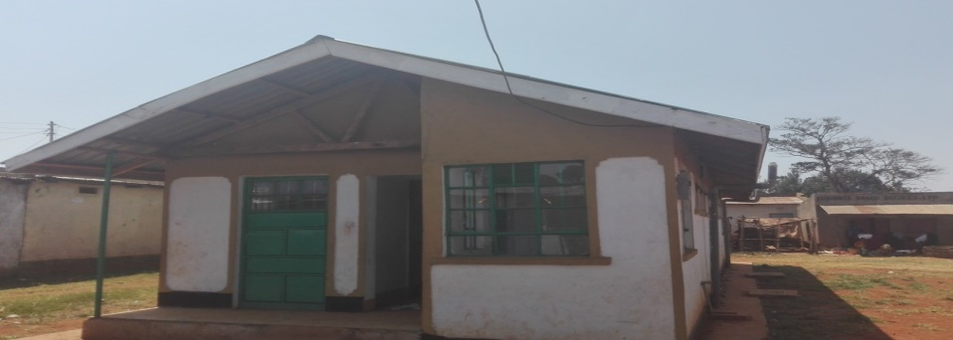
8 complete Eco toilet at Dudi trading centre
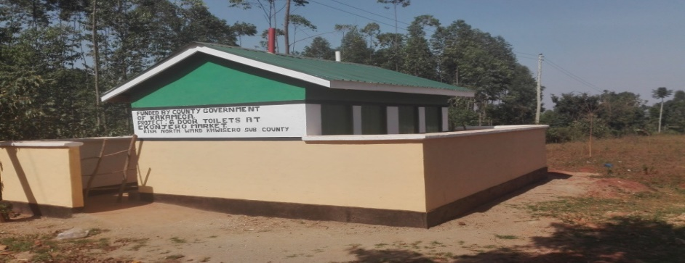
9complete 6 door toilet at Emasatsi trading centre

Project name | Location | Activities | Status | Remarks
Mulwanda Modern Market | Kisa Cental | Construction of modern market at Mulwanda Trading center | Complete | In use
Dudi Market | Kisa West | Refurbishment of Dudi Market | Complete | In use
Khwisero Market | Kisa Central | Refurbishment of Khwisero Market | On going | Refurbishments are on going
Stock ring | Kisa Central | Khwisero Central market | Complete | In use
Ekonjero market | Kisa North | Construction of 6 door toilet | Complete | In use
Emasatsi market | Kisa North | Construction of 6 door toilet | Complete | In use
Khusukulu market | Kisa West | Construction of 6 door toilet | On going | Under construction
Dudi Market | Kisa west | Eco-Toilet Dudi Market | Complete | Complete waiting official commissioning
Misango Hills | Kisa East | Gazettement and Development of Misango Hills | Gazetted | Gazettement is complete
MIKOPO MASHINANI | Khwisero | Disbursement of trade loans to SMEs, | On going | 599Traders benefitted from Kshs. 4M disbursed to the Sub- county where each ward received 1M shillings

Ministry of Water, Environment and Natural Resources
The goal of the water Sector is to improve access to quality and affordable water within the county as performance of key sectors in the economy especially agriculture, livestock, manufacturing and tourism depends on the availability of adequate quantities of safe water.
The environment Sector’s main objective is to ensure Environmental Conservation. The sector has made tremendous efforts in ensuring a clean and safe county which includes establishment of a Land fill to enhance Waste Recovery systems, development of County Environmental legislations to guide in Environmental Management, mass environmental awareness campaigns to sensitize citizens on environmental conservation, Engaging Organized Youth and Women groups in rendering cleaning services in the County Offices and Market Centers Countywide and implementation of a waste management strategy that embraces the 3Rs principle (Reduce, Reuse and Recycle).
The Natural Resources Sector deals with conservation of forest resources, water catchment protection and sustainable utilization of County mineral resources and formulation of regulations and policies that encourage sustainable utilization of Natural resources. The Sector has been able to increase county tree cover by planting 430,000 trees in public institutions, river banks and hill tops.
The projects undertaken in Khwisero Sub-County are listed below;
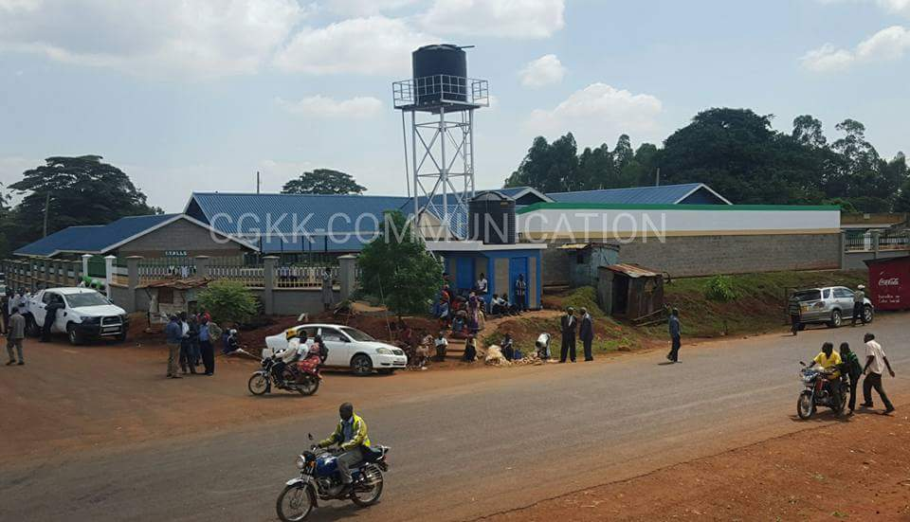
Figure 4 water connected at Mulwanda market

Project/  Programme | Location | Activities | Status | Remarks
Water
Mulwanda Market Water Supply Project | Kisa Central Ward | -Fabrication and installation of 8 M high steel tower hoisting 10 M³ plastic tank  -Supply and installation of Rising main and distribution pipelines | Complete | Complete and Operational
Mulwanda Market Water Supply Project | Kisa Central Ward | -Construction of 1 No. Water Kiosk | Complete | Complete and Operational
Mwihila Water Supply Project | Kisa North Ward | -Supply and Installation of Submersible electrical Pumping Unit  -Supply and Installation of Rising Mains and Distribution lines  -Repairs to intake springs and clear water sump | Complete | Complete and Operational
Spring Protection | Across the Sub-County | Construction of Springs | Complete | Over 15 springs protected
Environment
Youth Empowerment  (Kazi Mashinani) | Across the Sub-County | Cleaning Markets, County Offices and Urban Areas of the Sub-county | On going | 20 Youth & Women employed
Natural Resources
Greening of Schools, Hill tops and Riparian Land Reclamation | Across the Sub-County | Planted 1,000 Indigenous and Exotic trees in 2 Schools per ward and 15,000 on Misango Hills | Complete | 8 schools benefited with 1000 trees each

Ministry of Social Services, Youth and Sports

The main objective of the Ministry of Social Services, Youth and Sports is to promote, preserve and develop all functional aspects of Culture for Sustainable development, to coordinate care, protection and welfare of Children in the County, to develop and promote sports activities in the County, to maximize the full potential of Youth and Gender mainstreaming through participatory engagements that serve their needs and aspirations in building a better County, to develop and implement policies and programmes for a highly productive workforce through enabling environment and to establish, promote, equip, manage, maintain and develop Library Services in Kakamega County.

The table below shows the projects/programmes implemented by the department since devolution in Khwisero Sub County
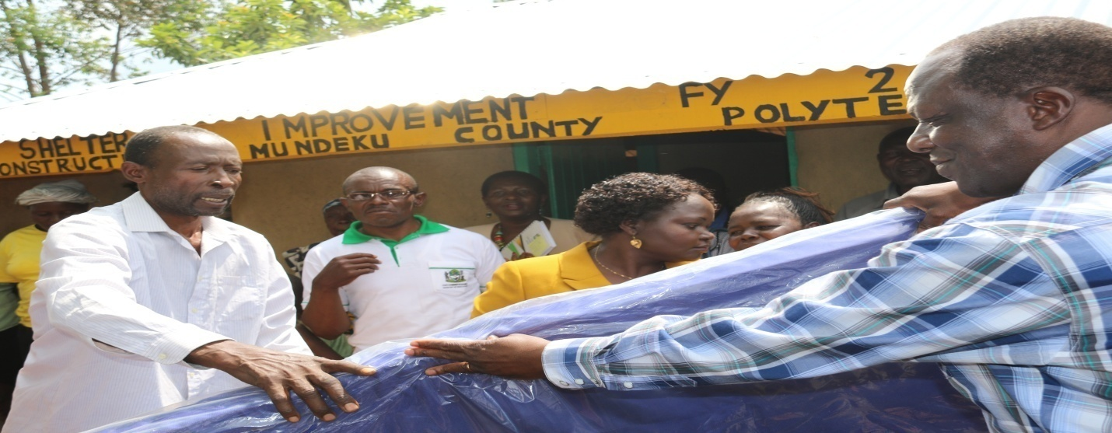
Figure 5 H.E issuing beddings under shelter improvement programme

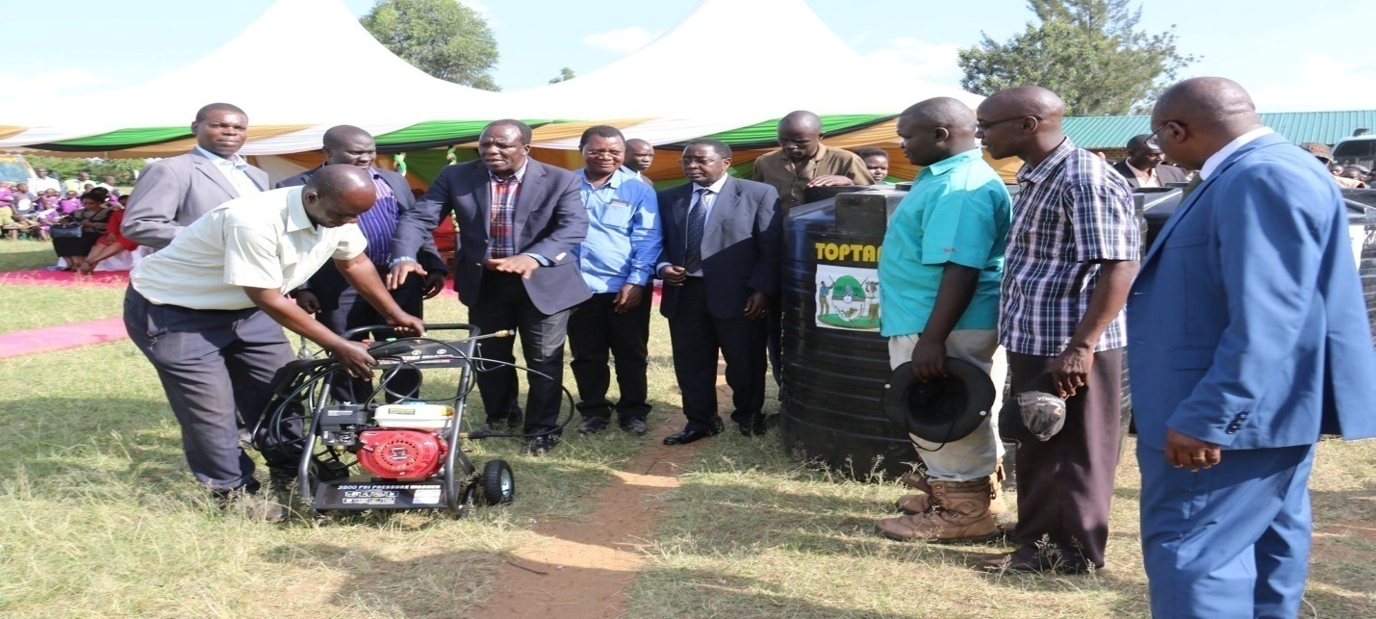
Figure 6H.E issuing Man make pump to Youths

Project/  Programme | Activities | Location | Status | Remarks
Provision of Money Maker pumps to Youth Groups | Purchase and distribution of money maker pumps | All Wards | Complete | 20 Money Maker pumps were procured and donated to youth groups to promote horticulture production
Provision of high power car wash machines to youth groups | Purchase and distribution of car wash machines and water tanks | All the Wards | Complete | 4 High Power car wash machines were procured and distributed to youth groups in all the wards. Allocated more machines because it is an urban setting.
Promotion of Youth talent | Youth Talent identification and nurturing phase I&II | All wards | Complete | 160 talented youth trained and nurtured.
Road Safety campaign for Boda Boda Motor bike operators | Sensitize Boda boda operators on road safety. | All wards | Complete | 160 boda boda trained on road safety but not issued with Driving Licenses.
Capacity building programme for the Youth | Sensitize youth, women and PWDs on Gender Based Violence and entrepreneurial skills and Substance and Drug abuse | All wards | Complete | 200 youth and women and PWDs sensitized
Music and Cultural Festival | Conducted County Music and Cultural Festival at the County. | County wide | Complete | 2 groups participated in the County and National Festivals
Shelter Improvement Programme for the Elderly and vulnerable | Construction of low cost housing units (6 Units per Ward) | All wards | Complete | Works completed. 24 houses were completed and handed over to the beneficiaries. On top of that each beneficiary received one mattress and two blankets
Promotion of Sports activities through the Governor’s Cup | Conducting of the 2 Annual Governor’s cup sporting festival  Purchase of sports equipment | All ward | Complete | Promotion of sports talent through the Governors Cup Sporting festival that started at the ward level. 624 youth from all the four wards participated at the Sub County level. Male and Female netball champions 2015/16  The teams benefited were provided with uniforms, balls and boots
Training of Coaches | Conducting of training clinics to coaches from all the three disciplines ( Football, Volley ball and Net ball) | All Wards | Complete | 12 Coaches were trained in all the three disciplines
Training of Coaches | Payment of Honoraria to sports centre coaches | All wards | On going | 4 Youth Centre coaches from Khwisero receive Kshs 2,500/= monthly payment to appreciate their contribution in nurturing youth sports talent.

Ministry of Public Service and Administration

This ministry has the following departments; County Administration, Public service, Enforcement, Sub County Administration, Ward administration, Villages administration and Directorate of Alcoholic Drinks. The ministryis charged with the responsibility of establishing administrative structures with systems, mechanisms and procedures that would help the county discharge all devolved functions.
The ministry has so far implemented various projects and programmes in Khwisero Sub-counties since devolution
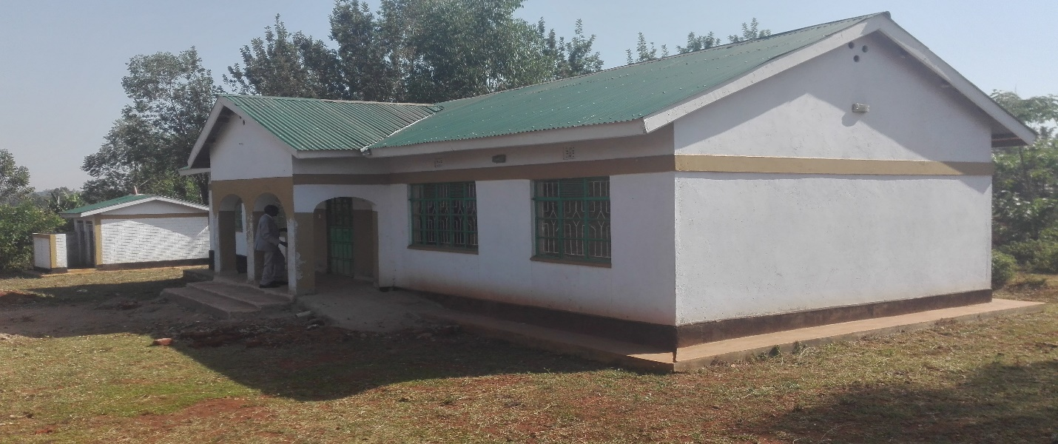
Kisa-North Ward Office
Project name | Activities | Location | Status | Remarks
Ward office | Construction | Kisa North | Complete | occupied
Ward office | Construction | Kisa west | Ongoing | Awaiting finishing
Kazi Mashinani Programme | Employ kazi mashinani guards, ordination of other kazi Mashinani programs | Per ward | Complete | 12 Mashinani guards employed
Shirali primary school | construction of 4 classroom which were blown off | Kisa-Central | complete | operational
Mundoli primary school | refurbishment of 7 classroom | Kisa Central | complete | operational

