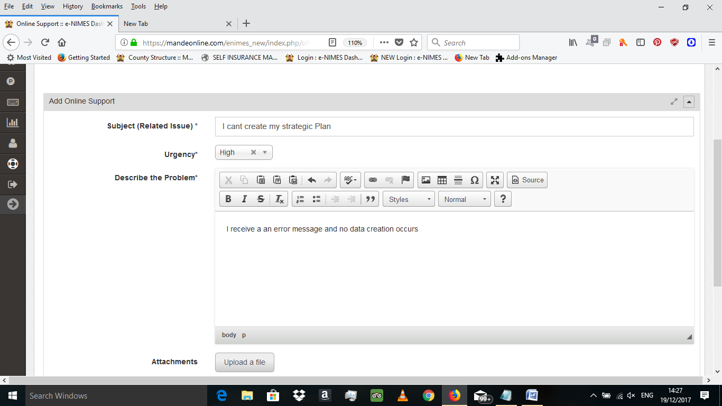

Here’s is the print screen of the error I am recieving

