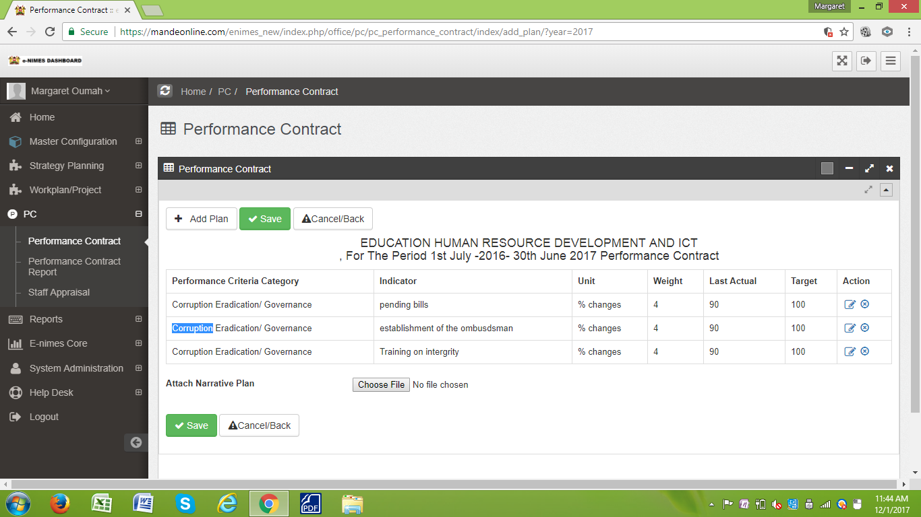

Kindly take note that im not able to edit

