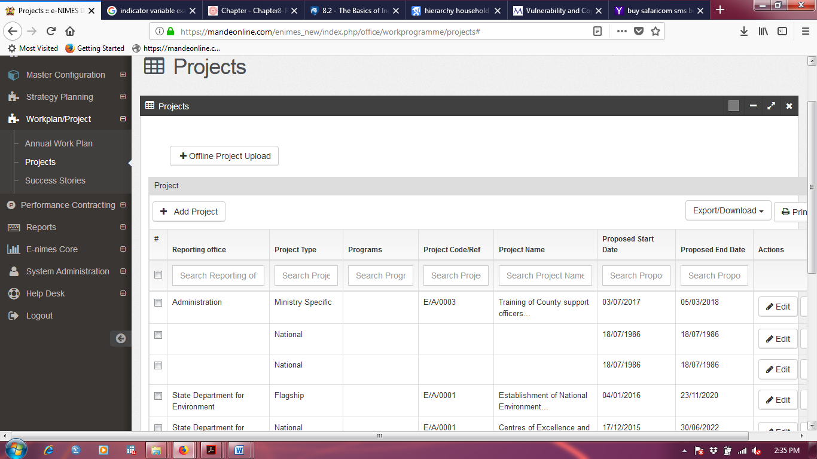
kdkdkdkdjdhskidnskmdkmsmdm

